Mod 6:

|  |  |  |  |  |  |  |  |
| --- | --- | --- | --- | --- | --- | --- | --- |
| Reset | Inc | Q2 | Q1 | Q0 | Q2+ | Q1+ | Q0+ |
| 0 | 0 | 0 | 0 | 0 | 0 | 0 | 0 |
| 0 | 0 | 0 | 0 | 1 | 0 | 0 | 1 |
| 0 | 0 | 0 | 1 | 0 | 0 | 1 | 0 |
| 0 | 0 | 0 | 1 | 1 | 0 | 1 | 1 |
| 0 | 0 | 1 | 0 | 0 | 1 | 0 | 0 |
| 0 | 0 | 1 | 0 | 1 | 1 | 0 | 1 |
| 0 | 1 | 0 | 0 | 0 | 0 | 0 | 1 |
| 0 | 1 | 0 | 0 | 1 | 0 | 1 | 0 |
| 0 | 1 | 0 | 1 | 0 | 0 | 1 | 1 |
| 0 | 1 | 0 | 1 | 1 | 1 | 0 | 0 |
| 0 | 1 | 1 | 0 | 0 | 1 | 0 | 1 |
| 0 | 1 | 1 | 0 | 1 | 0 | 0 | 0 |
| 1 | X | X | X | X | 0 | 0 | 0 |

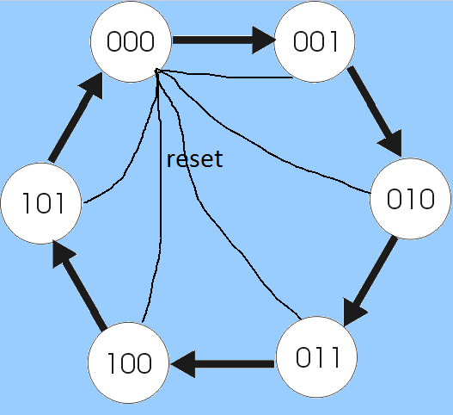

Q2+:

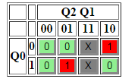

Q2+ = Q1 Q0 + Q2 Q0’

Q1+:

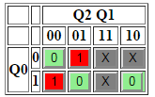

Q1+ = Q1 Q0’ + Q2’ Q1’ Q0

Q0+:

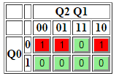

Q0+ = Q2’ Q0’ + Q1’ Q0’

Mod 10:

|  |  |  |  |  |  |  |  |
| --- | --- | --- | --- | --- | --- | --- | --- |
| Q3 | Q2 | Q1 | Q0 | Q3+ | Q2+ | Q1+ | Q0+ |
| 0 | 0 | 0 | 0 | 0 | 0 | 0 | 1 |
| 0 | 0 | 0 | 1 | 0 | 0 | 1 | 0 |
| 0 | 0 | 1 | 0 | 0 | 0 | 1 | 1 |
| 0 | 0 | 1 | 1 | 0 | 1 | 0 | 0 |
| 0 | 1 | 0 | 0 | 0 | 1 | 0 | 1 |
| 0 | 1 | 0 | 1 | 0 | 1 | 1 | 0 |
| 0 | 1 | 1 | 0 | 0 | 1 | 1 | 1 |
| 0 | 1 | 1 | 1 | 1 | 0 | 0 | 0 |
| 1 | 0 | 0 | 0 | 1 | 0 | 0 | 1 |
| 1 | 0 | 0 | 1 | 0 | 0 | 0 | 0 |

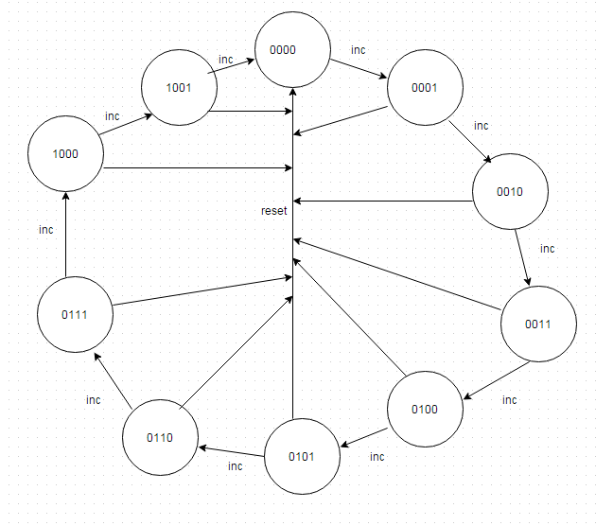

Q3+:

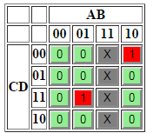

Q3+= Q2Q1Q0 + Q3Q1’Q0’

Q2+:

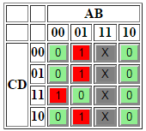

Q2+ = Q2Q1’ + Q2Q0’ + Q3’Q2’Q1Q0

Q1+:

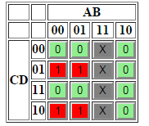

Q1+ = Q3’Q1’Q0 + Q3’Q1Q0’

Q0+:

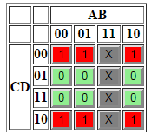

Q0+ = Q0’

SR Latch:

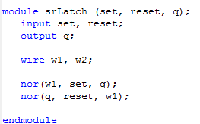



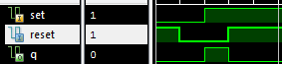

Mod 6:

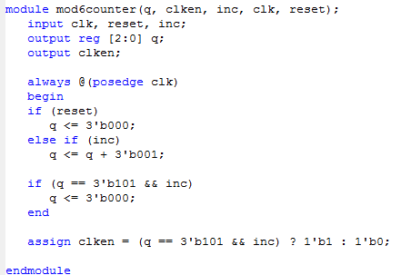



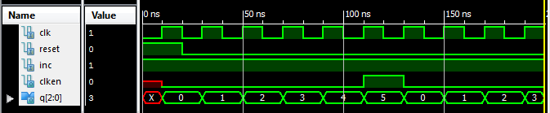

Mod 10:

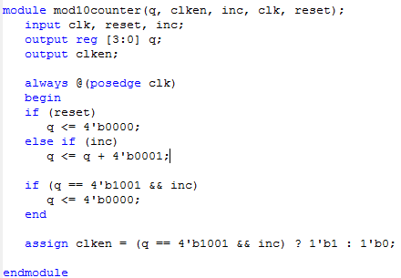



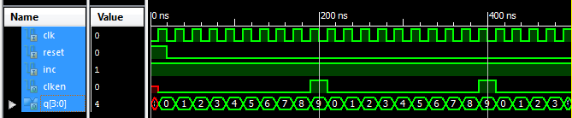

Counter Block:

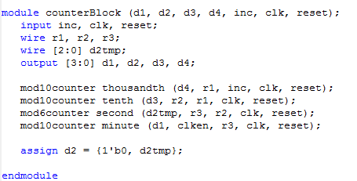



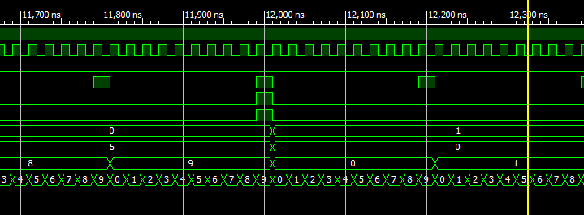

Test Bench:

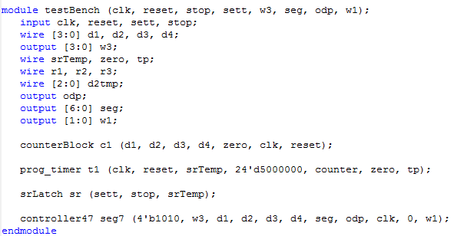



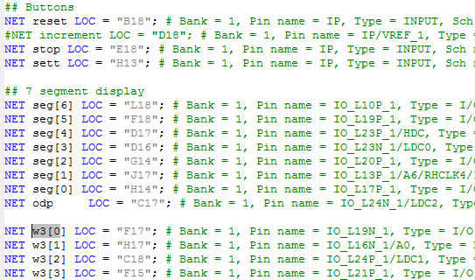

Anomalies:

I was sending set (start) and reset into my srLatch (probably because of the name: set and reset latch) but I really needed to send my start and stop signals. Just a little confusing.

The instructions for this lab probably should be re written as they were very hard to follow.

The flip flop in the preparation section was totally unrelated to the lab?